AI for Healthcare Systems Specialization
Learn to Apply AI in Healthcare. Master strategies and tactics for broad application of AI in healthcare organizations.
What you'll learn
- Build practical skills to design, evaluate, and apply AI solutions responsibly for healthcare’s most pressing challenges.
- Harness AI and analytics to transform healthcare systems, improve decisions, and address real-world health challenges.
- Develop the skills to model, design, and apply AI responsibly in advancing healthcare innovation and patient outcomes.
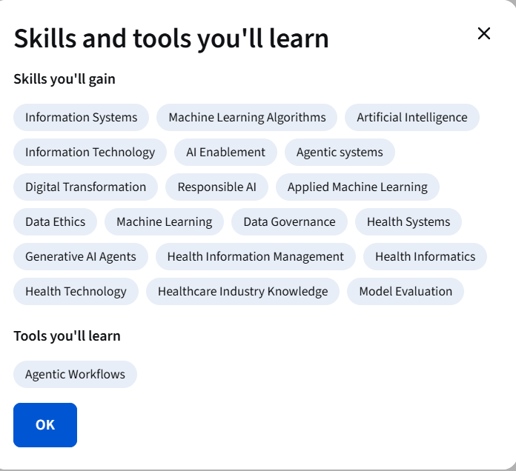

Specialization - 4 course series
AI for Healthcare Systems is a comprehensive exploration AI-relevant tools, applications and systems for mid-career healthcare and other professionals interested in this topic. This specialization benefits learners beginning to explore a career in AI for healthcare or to gain more knowledge. Systematically using analytics, reporting tools, and data visualization techniques help healthcare organizations with comprehensive insights that support better decision-making and optimizing performance. In turn, AI enhances the capabilities of healthcare professionals and systems, contributing to a more effective, efficient, and patient-centered healthcare system.
Applied Learning Project
Learners will start by understanding AI as a process of intelligent decision-making that can solve several challenges in health systems. Then learners will discuss how health organizations strategically use AI for decision-making rather than just as another tool or application.
